Creating Email Templates
Objective
After completing this lesson, you will be able to create email templates for various communication needs within SmartRecruiters.
Overview of Email Template Types
Email templates in SmartRecruiters are predesigned email structures that permissioned users (e.g., Recruiters or Hiring managers) can use to quickly and consistently communicate with candidates. These templates eliminate the need to write the same emails repeatedly, ensuring a uniform message across all candidate interactions.
When communicating with a candidate, you have several options for sending emails. You can manually type an email in the Send via email section, or you can select a pre-existing template. These templates streamline communication with candidates, ensuring consistency and saving valuable time. Whether you're requesting additional information, scheduling interviews, or extending job offers, email templates provide a standardized and professional way to interact with potential hires.
Template Types
Template types in SmartRecruiters are predefined formats for sending specific communications to candidates and other stakeholders throughout the hiring process.
These templates cover core activities, including interview scheduling, job offers, rejections, and general messaging. They help ensure consistent, timely, and relevant updates at each recruitment stage and can be customized to suit different workflows or organizational needs.
- Generic email templates are used for ad hoc communications, such as requesting additional information or informing candidates that a job is being put on hold. These templates can be accessed from the Communication tab within a candidate's profile.
- Interview email templates are used when scheduling interviews. These templates include interview invites and, if your system is configured for calendar integration, invitations for candidates to self-schedule.
- Offer email templates are used when extending job offers to candidates. These templates are used when an offer is created and approved.
- Rejection email templates are used when informing candidates that they will not be moving forward in the hiring process.
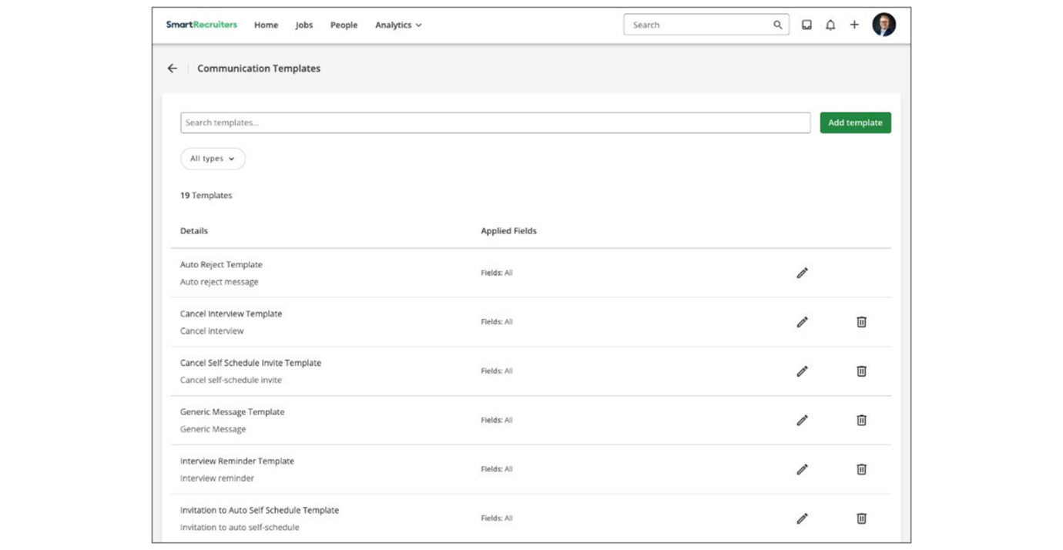
Create Email Templates
To create a new communication template:
Steps
- Navigate to Settings.
- Within the Templates section, select Communication Templates.
- Select Add template.
- In the Name field, enter a descriptive name. The recommended practice is to follow a naming convention if the customer will be maintaining templates in multiple languages and countries, to ease users' experience, but also ease their maintenance from an admin perspective (e.g., Interview_On Site_ EN or Interview_Video_Germany_EN).
- In the Type field, choose one of the template types for the template. Remember that the type you choose determines where and when your hiring team can use it.
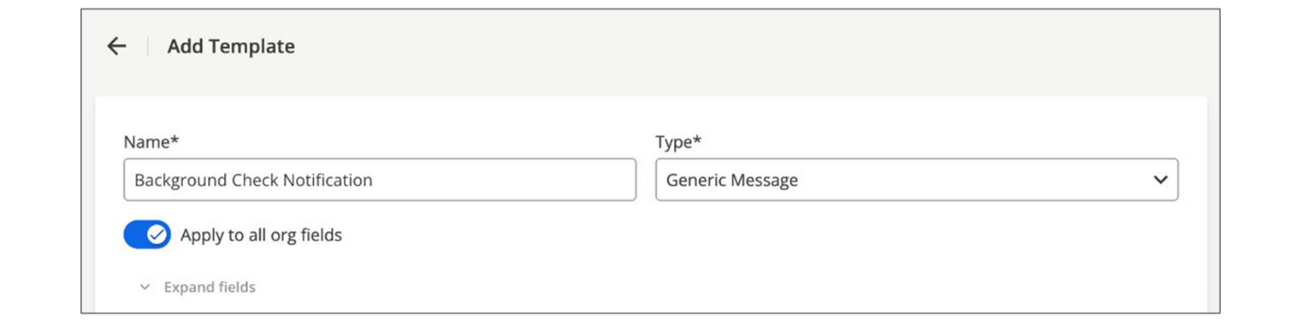
- Enable or disable the Apply to all org fields toggle. If you disable the toggle, select which fields and values the Template should apply to.
  - By default, each email template is available for candidates on any job. Using this setting, you also have the option to designate individual templates for specific groups of job. For example, one interview invitation template for engineers, and one for marketing. It is also possible to restrict a list of email templates to choose from.
  - Select values for each active Org field. You can select multiple values, a single value, or all values for each field.
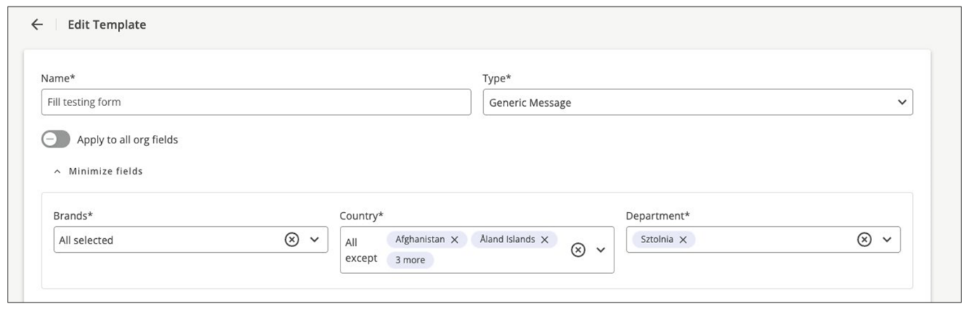
- In the Subject field, enter an email subject.
- In the rich text editor, enter the message body. You can add Merge fields to both the subject and the message body to customize the template and include information about the candidate, the job, or your company.
- Select Save Template.
Once created, email templates are immediately available for use. You can edit or delete templates as needed to keep them up to date and relevant.
Watch the video below for more details about creating email templates.
This video is for demonstration purposes. Any references made in this video to previous or later videos in this course (including titles, numbers, links, or sequence) may differ from the current course structure. Additionally, some functionalities shown may have evolved over time due to ongoing enhancements or business decisions.
Summary
- Email templates in SmartRecruiters are predesigned email structures that recruiters can use to quickly and consistently communicate with candidates.
- SmartRecruiters offers several template types, including generic, interview, offer, and rejection email templates.
- Email templates ensure consistent, timely, and relevant updates at each recruitment stage and can be customized to suit different workflows or organizational needs.
- Templates can be assigned to specific groups of jobs based on organizational fields.
- Merge fields can be added to both the subject and message body to customize the template with information about the candidate, job, or company.
Hi, in this video, we're going to take a look at email templates
in SmartRecruiters. So when we want to email
a candidate, there are a number of places that
we can do that from. First, if I select the email
tab, then I can, of course, just free type an email here. But
I can also select a template. In this case, I've got an additional
information template available. And this, of course, makes it quick
and easy for our users to be able to send out standard communications.
So these are what we call generic email types, whereby we
may want to send out an additional information request. Maybe we want
to send out something if we put a job on hold. We can have those
templates available here. Of course, when we schedule an interview, we
have interview templates that we want to send out to a candidate.
So we schedule the interview and we obviously add an invite. So here
I can select my interview invites. The other option that you will have
available to you if you have the calendar integration configured in
your system, is the invitation to self-schedule. So you'll actually
have two different interview types available to you there and I'll show
you where this is in back end in just a moment. So I'm going to
come out of here, so generic emails, interview emails. Of course we have
the offer email so when we go ahead and we create an offer and it gets
approved if we're using approvals. Once we're ready to send that out
to the candidate, we can send it via email. And when we do so, we
can then select from our offer template types here. And in this case,
I've just got a offer letter formal that's available. And that pulls
that email through there for me. And then finally, of course,
if we're going to reject a candidate, we also have rejection
templates that are available for us. So in this case, I've
got a number I can select from here that I can then go ahead
and send out to my candidate. So where do we configure these?
Back in settings and admin, underneath the templates
tab, we have email templates. So email templates are where
we can create those different templates we've just looked
at. And when you come into this list here, you'll see you can
filter between your generic, your invitation to job interview. You'll also have the self-schedule
invitation there if you have the calendar integration and then
job offers and rejections so when I create a new template as well
as of course adding in the subject and the message I need to select
the type that it's going to be so is this something that I'm going
to have users send as a generic you know it's an ad hoc type of
email that would be sent or is it for one of these specific
events so in this case I'm going to say it's a generic email. I'm
going to create a referee request. Again, we've got org fields
available here. So whilst these are triggered by a user, so they're not
automatically assigned. Of course, we only want to have users see email
templates that are applicable to the jobs and the candidates they're
actually working with. So if this particular email would only ever
be sent to candidates based in a particular region or country or any
other kind of event that you have an org field for, you can update
your filters as usual. You can then add in your subject heading and
you can then put in the body of the email. So exactly the same as with
our auto replies, you can come in and you can type or copy and paste
the content in here. You can use your merge fields that are available
to pull in some of that standard information. And in this case, I'm
just going to ask them to complete the referee request form and I can then add in the form that I want to send them and then of course sign off as needed. Now the difference here from the auto
-reply is that because a user will be triggering this, I do have a
merge field available to have it come from the user that's actually
generating it. So I can come in and add in my first name, my last name.
Oh, I've just overwritten that tag. And that will actually pull
through the name of the user that's sending it.
Again, we've got our normal formatting options available,
along with the ability to add in attachments or links and
any images that we need. Once I have completed everything
there I can go ahead and save and that email template will be available
immediately to use. With all of your email templates here at any
point in time you can delete them if they're no longer required and of
course you can edit them as needed. So that's how we can create our
email templates in the system so these are the ones that are
triggered around those events we just looked at. We'll take
a look in a later video at how we can create the email
templates that we might want to associate with a workflow within
our hiring process. Thank you.

Configuring Automated Email Notifications
Objective
After completing this lesson, you will be able to configure automated email notifications with templates for candidates and internal team members.
Custom Automated Notifications
In SmartRecruiters, custom automated email notifications are a powerful tool for automating communication throughout the hiring process. These notifications can be triggered at specific steps in a hiring process, ensuring that candidates and internal team members receive timely, relevant information.
Using custom automated email notifications, users can send messages within a particular step in the hiring process, where workflows can be added. These messages can be sent to a candidate, a hiring team role, or a named user. This is particularly useful for reminding hiring team members to complete tasks or for prompting candidates to get in touch or complete a form.
The following automated notifications can be created:
- Candidate Emails: You can create and manage email templates designed for candidates. For example, you might have a template for requesting additional information from a candidate. These emails will be triggered when you attach them to a message task in the hiring process workflows. Once saved, the template will be available for selection in the workflow.
- Internal Emails: You can also create and manage email templates for internal team members. Examples include candidate review notifications sent to the hiring manager or reminder emails. Once your internal email template is saved, you can add it to a message task in the workflows of your hiring process.
When managing automated notification settings, you will be able to:
- Create New templates (you need to be on the Candidate or Internal communication tab), to create a related template.
- Edit templates by clicking on the pencil icon in the selected template row.
- Search through existing templates already created by using the search by option (by template name); remember to be on the correct tab to see the relevant search results.
- Filter (on the Candidate communication tab only) by communication channels: Email, SmartMessage.
Create an Automated Notification Template
Before configuring an automated workflow to send a candidate or internal hiring team member a notification, you will need to create a template.
Steps
- Navigate to Settings.
- In the Templates section, select Automated Communication.
- Select Candidate communication to create a template for candidates, or Internal candidate to create a template for an internal hiring team member.
- Select Add template.
- In the Name field, enter the template name. This must be unique.
- In the Subject field, enter the subject of your email.
- In the Editor field, enter the text to display in the email. You can also include:
  - Merged fields (When you use an email template, SmartRecruiters fills each merge field in the template with information about you, your company, or the candidate.)
  - Forms
- Select Save.
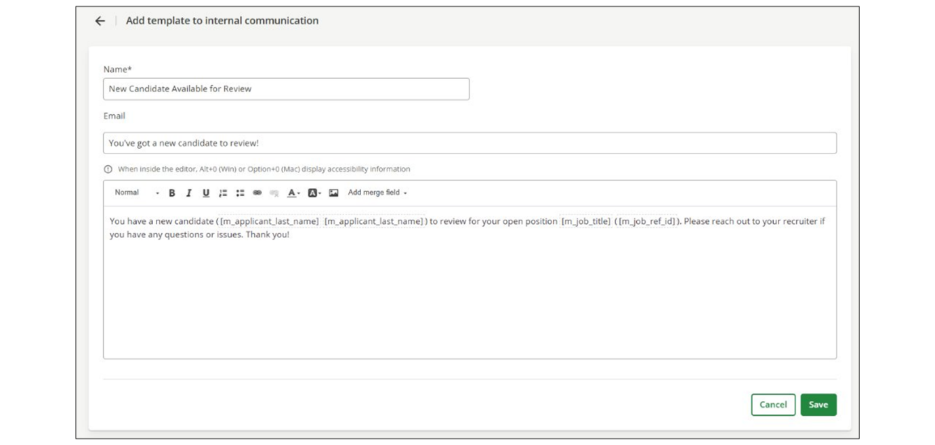
Note
Notifications that are set up here will not be visible in the template dropdown for recruiters/coordinators to send to candidates on an ad hoc basis in the Communication tab of the candidate profile or through the inbox.
Assign an Automated Notification to a Workflow
To ensure the notification is automatically sent based on recruiting-related actions, create an automated workflow rule.
Steps
- Navigate to Settings.
- In the Configuration section, select Hiring Process.
- Select Edit in the row of the hiring process for which you want to add an automated notification.
- Within the hiring process, select the Step at which the notification should be sent.
- Select Workflows from the menu.
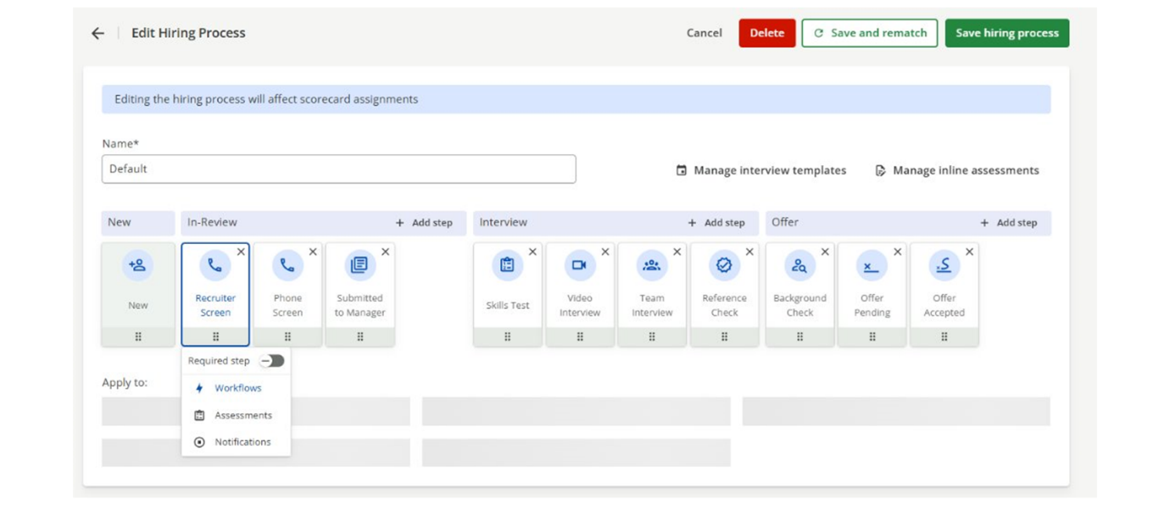
- Drag and drop the Send Message tile into your workflow.
- Within the Send Message configuration, you can complete the following configurations:
  - Add a condition.
  - Choose the recipient.
  - Choose the communication template (only templates created within the Automated Communication page in Settings will appear).
  - Add filter rules to specify when the notification is sent, and how often the notification it is sent.
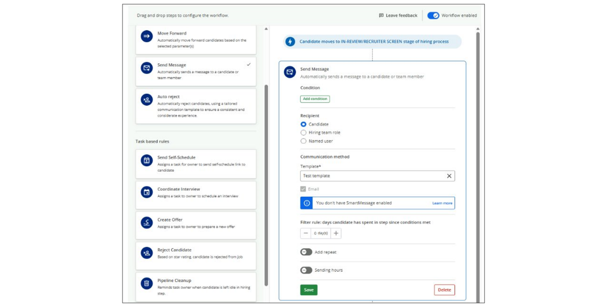
- Select Save.
Watch the video below for more details about creating custom email notifications.
This video is for demonstration purposes. Any references made in this video to previous or later videos in this course (including titles, numbers, links, or sequence) may differ from the current course structure. Additionally, some functionalities shown may have evolved over time due to ongoing enhancements or business decisions.
Summary
- In SmartRecruiters, custom automated email notifications are a powerful tool for automating communication throughout the hiring process.
- Communications can be triggered at specific steps in a hiring workflow, ensuring timely, relevant information for candidates and internal team members.
- Users can create and manage email templates designed for candidates and internal team members.
- Automated communications are assigned to workflows within specific steps of the hiring process.
- Templates created within the Automated Communications page in Settings are used for automated communications.
Hi, in this video, we're going to take
a look at custom email notifications in SmartRecruiters. One of
the features available within a particular step in the hiring process
is that we can add workflows. And one of the items we're able to
add there is the ability to send a message. And this is something that
can basically be sent out to either a candidate, to a hiring team role or
to a named user. So this is great because it means, you know, maybe
there's a particular stage in the process. I want to remind a hiring
team role user to do something, or perhaps I want to send an email
out to the candidate to ask them to get in touch or complete a form. So
it means that we're able to configure those to automatically be sent. So
we looked at how we could activate these here, but we know that we
need to have an email template to be able to select for that particular
task. So these email templates are configured within of course
settings and admin underneath templates and then the custom email
notifications. So with the custom email notifications we've got two tabs.
We have those that we would send to candidates and those that we want
to send internally. So with our candidate emails I can see I've got
one here for additional information. Not much content in here but the
purpose of this email is that during a particular stage in the
hiring process, I can trigger an email to go to the candidate
to ask them to complete this form. So if I want to create a new
email notification, I can select the Create New button. You'll
see here, I can choose whether this is an internal or candidate
notification type, and then I can give my email template a
name. So maybe this is going to be when I send out referee request,
and then I would enter my subject heading as normal. Enter the actual
body of the email so pretty much the same as the other emails we've looked
at creating, except this time our formatting options stand at the
bottom here. So I'm just going to add dear and then here I've got my
merge field, so I can come in and add my candidate name. And then I'll just
in this case, say please complete. And then I can add my
referee information form, so nothing more complicated than what
we've looked at so far. It's just that these emails will be triggered when
you attach them to that particular message within the workflows of
the hiring process. So I can then go ahead and save this, so that's now
available for me here. But if I go to my internal tab you can see I've
got a candidate review that's sent out to the hiring manager and along
with a hiring manager reminder email here. And again if I want to create
a new one I can just come through to create new automatically defaults
to internal because I've come through them from that tab. And again I can
come in and name my template and add in the body of the text. The
only thing I won't have available to me here are the forms because the
forms of completion by candidates only. Once I have my template saved, they'll
then be available for me to add to that message task within the
workflows within our hiring process.

Creating Automated Replies
Objective
After completing this lesson, you will be able to configure automated replies for external and internal candidates.
Automated Replies in SmartRecruiters
Ensuring timely, personalized communication with job applicants is crucial to maintaining a positive candidate experience. SmartRecruiters lets you set up automated replies that acknowledge applications and provide essential information, enhancing engagement and streamlining the recruitment process.
SmartRecruiters' Auto-Reply feature helps you maximize candidate engagement by automatically responding to each new application with a custom message.
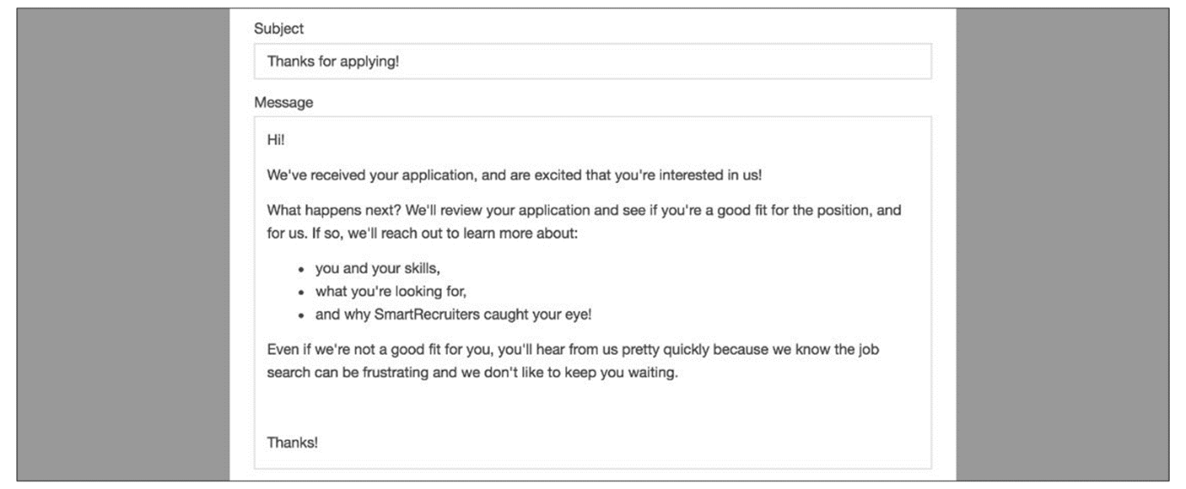
Auto-Replies provide an automated way to immediately engage the candidate, set expectations for follow-up steps such as phone screens, and introduce your company's culture. When a candidate applies for a job, SmartRecruiters will automatically send an Auto-Reply to the email address they provide on their application.
Each job can have one Auto-Reply branded with your company’s name. The Auto-Reply can also contain a link to the Candidate Portal so that the candidate can access their application(s).
External vs. Internal Auto-Replies
SmartRecruiters distinguishes between two types of candidates:
- External Candidates: These are applicants who apply through public job postings, such as those on your career page or job boards.
- Internal Candidates: These are employees applying through internal career portals or widgets on your intranet.
Create Auto-Reply Templates
The creation process is similar for both external and internal auto-replies.
Steps
- Navigate to Settings.
- Select Auto-Reply in the Templates list.
- Select Create Template.
- Give the template a name.
- Select Template Type: External auto-reply or Internal auto-reply.
- Assign the template to a specific group of jobs by selecting values for your active Org fields. You can match values for any of your company’s active Org fields, plus the default Brand and Country fields.
- Compose the email template:
  - Subject Heading: Enter a clear and engaging subject line.
  - Email Content: Use the formatting options to create a well-structured and informative email. You can add paragraphs, headings, and bullet points. SmartRecruiters’ text editor supports basic HTML formatting (bold, italics, lists, headings, links), but does not currently support images or colors.
  - Merge Fields (Optional): Personalize the email by using merge fields to include the candidate's name, job title, or company name. For example, you can address the candidate by their first name and mention the job they applied for.
  - Add Attachments (Optional): If you need to send additional documents, such as company brochures or application guides, you can upload them as attachments. These will appear as downloadable links in the email.
  - Include Forms (Optional): For gathering additional information, you can include a link to a form. This is typically used later in the recruitment process, but can be added to the auto-reply if needed.
- Once you're satisfied with the email, save the template.
Multiple Auto-Reply Templates
You can create multiple auto-reply templates based on different organizational fields, ensuring that candidates receive the most relevant and personalized communication. If a candidate's application matches multiple criteria, SmartRecruiters will send the most specific template. If no specific template matches, the default template will be sent.
Note
Auto Replies cannot be set up solely based on the language of a job ad. However, users in SmartRecruit accounts can set up auto-replies for a specific region, country, or other Org field, which might dictate the language for the job ad, and allow the template to be written in the appropriate language.
For example, you may configure an auto-reply for the engineering department that includes specific information about the following steps in that hiring process, and a separate auto-reply for the product department with different information.
Watch the video below for more details about creating auto replies.
This video is for demonstration purposes. Any references made in this video to previous or later videos in this course (including titles, numbers, links, or sequence) may differ from the current course structure. Additionally, some functionalities shown may have evolved over time due to ongoing enhancements or business decisions.
Summary
- Configuring auto-replies in SmartRecruiters enhances the candidate experience by providing immediate acknowledgment of their application.
- Auto-replies can be customized for both external and internal candidates, allowing for tailored communication.
- Organizational fields enable the creation of specific auto-replies based on criteria such as location, department, or brand.
Hi, in this video, we're
going to take a look at auto -replies and SmartRecruiters.
So, of course, when a candidate applies to a job, they receive
an email acknowledging their application. And we manage
those in Settings and Admin, underneath Templates and Auto-Reply. So, within the Auto-Reply area,
we have two tabs. We have the External Auto-Reply and then we
have Internal for our employees. So, our external candidates
are those who are applying via public job advert. So those that
are on our career pages, or we've sent to job boards, and then of
course our internal candidates are those who are applying via
the careers or employee portals or a widget perhaps that we
have available on our internet. For both we create them in exactly
the same way, so if we take a look first here at the external
auto reply, you can see that I have a default one here. And then I
have a South Africa auto reply for all departments except technology
and another one for the technology department which is the South
Africa tech auto reply. So again we use our org fields here to help
us build out in which situations the email should be sent. So of
course if you just want one email template sent out to your
candidates regardless of which job they've applied to or where you can
just have your default one. If you do want something more specific
then again we can add our custom ones. So I'm going to create a UK
auto-reply, and I'm going to use my country field here as always
to filter on the United Kingdom. Of course if this is going to
be for jobs associated with a specific brand or a department
or any other org field that you create, you can come
and add those filters here. And then I can come in and
just add in my subject heading, and then the actual email content
itself. So of course, I don't need to let you know how to create emails. But you can come in you've got formatting options available at
the top here. So you can add in you know normal paragraphs or headings,
normal text, but you can type you can copy and paste, and you can pull
in merge fields. So if I want to be able to of course acknowledge
the candidate by their name, and I can pull in this merge field here
for applicant first name. And you'll see that there are different merge
fields available for you here. So perhaps I want to say thanks
for applying to and then pull in the job title. So I'm going to
grab the job title from the list here, and of course I can then
add whatever else is needed. And then I can either put something
generic at the bottom here or I could perhaps just come in
and pull the company name. So of course in this particular case
there isn't a user of the system sending it so I can't pull in a
particular username and so here. I would just want to put you
know from the talent acquisition team or the recruitment team
whatever that might be. So I can come in I can add my text here, I
can format it using the options above here. o if I want to make
something bold of course or italic or underlined I've got bullet
point options. I can also add in a link so you know if I want to ask
them to keep an eye on a website, then I can come in and add a link
here. So I just need to add in the display text along with the URL.
The other thing I can do here is if there are any attachments that I
might want to send out, that I want the candidate to be able to download,
I can upload a file here, send it to the SmartRecruiters server, and
it will become then a downloadable link for the candidate to select
from. I can of course add in images if I want to add in brands,
if I want to change the colour of the text or the background, I can make
those updates here, and then the other option I have is to add a
form. So if I actually want to send out a form to the candidate to
capture additional information I can do that here. Typically these would
be later on in the process once we've actually started processing
the candidate. But if I do want to gather some additional information
at that stage I can simply grab the link to the form that I'd like them
to complete and add it in here. So once I go ahead and save this,
as soon as a candidate now applies to a job based in the United
Kingdom, this is the email they will be sent. My candidates applying
to my South Africa jobs will get one of these depending on
which department the job is based. Everyone else will receive
my default email. For our internal candidates, exactly
the same process. It's just that these are triggered
by our candidates who are applying to internal job
ads, so all of our employees. And so again, I can come in and
add my template in here. I've got my same org field filters.
So if I do need to set up different ones for different
countries, different org fields that I have there, I can do so. So
that's how we create our auto replies in SmartRecruiters.
We'll take a look later at additional email templates that
we're able to create. Thank you.

Configuring Email Domains
Objective
After completing this lesson, you will be able to configure email domain authentication settings.
Your Email Domain Authentication
Setting up an email domain for SmartRecruiters emails to candidates offers critical benefits centered on trust, deliverability, and employer branding. Authenticating your email domain in SmartRecruiters allows you to send emails to candidates from your own company's domain instead of the default @smartrecruiters.com domain.
Using a corporate email domain ensures a professional, consistent brand experience at every candidate touchpoint. Instead of emails appearing to come from a generic, third-party platform address, they clearly originate from your company's own domain. This reinforces your brand identity and conveys that the recruiting communication is official and trustworthy.
Note
This process requires access to your company's DNS records. If you do not have direct access, you will need assistance from your IT team.
Affected Emails
Authenticated email domain configuration applied only to emails to candidates. Below is the full list of emails the setting applies to:
Email | Type | Trigger By
Rejection to candidate | Conversation | Employee
Candidate appointment update | Conversation | Employee
General conversation email to candidate | Conversation | Employee
Interview invitation | Conversation | Employee
Offer to candidate | Conversation | Employee
Auto-reply after application | Notification | Candidate on application submission
Candidate application in review | Notification | System on candidate application moved to In Review status
Emails to candidate configured against workflows | Notification | System
Interview self-scheduling invitation | Conversation | Employee
General email to community application | Conversation | Employee
Referral | Notification | System
Referral confirmation to referrer | Notification | System
Consent request email | Notification | Employee or system
Consent request expired email | Notification | Employee, system, or candidate
Net hiring score survey | Notification | System
Employee app tracking - one time password | Notification | Employee
Add an Email Domain
Steps
- Navigate to Settings.
- Select Email Domain Authentication in the Configuration section.
- Select the Authenticate Domain button.
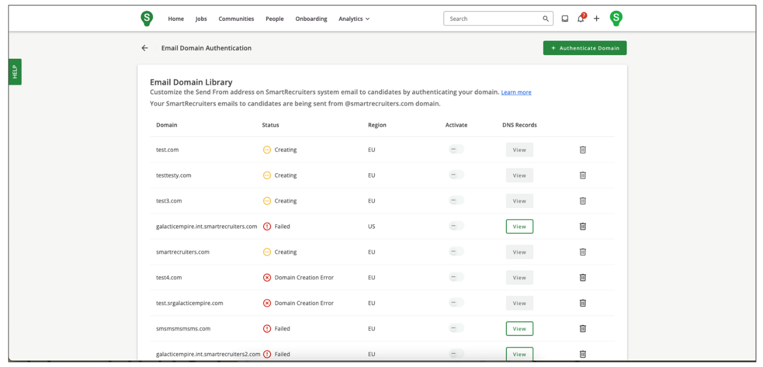
- Enter the valid, available domain you wish to use in the field Domain you send from.
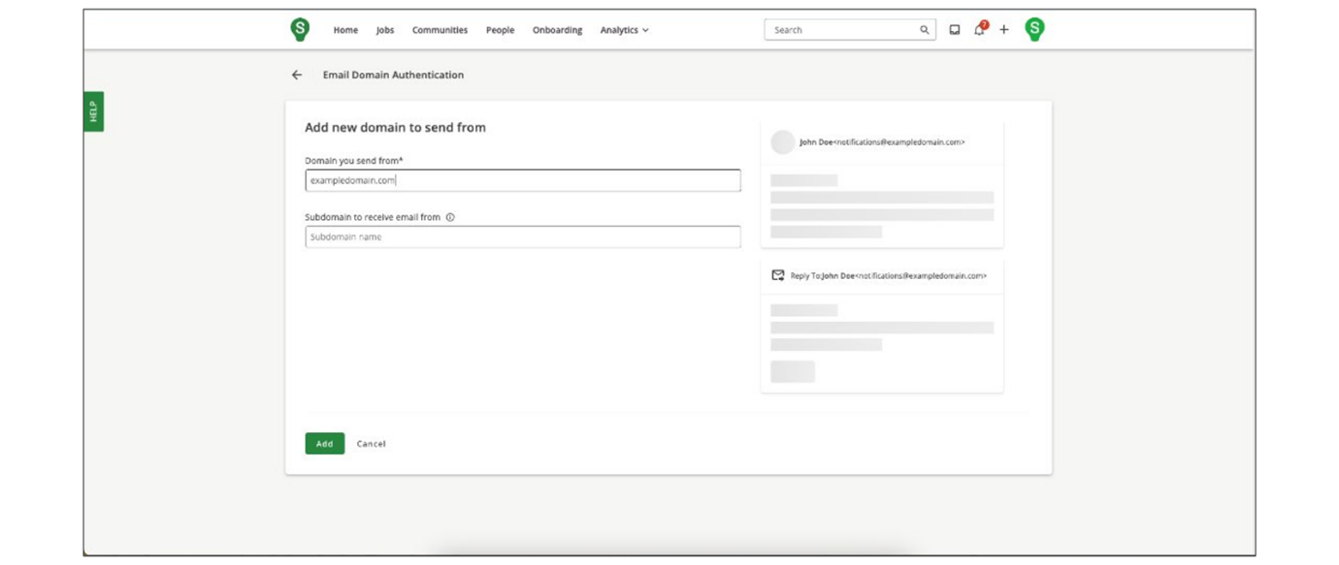
- Select Add to proceed to authenticate the domain access for SmartRecruiters email services.
  - If the MX record of the domain you wish to configure is already used, the Receive From Field (sub-domain) will be required.
  - The configured sub-domain affects the display of the reply-to email address. Specifically in the example below, if the sub-domain is configured as recruiting, the displayed reply-to email address will be changed to @recruting.srgalaticempire.com.
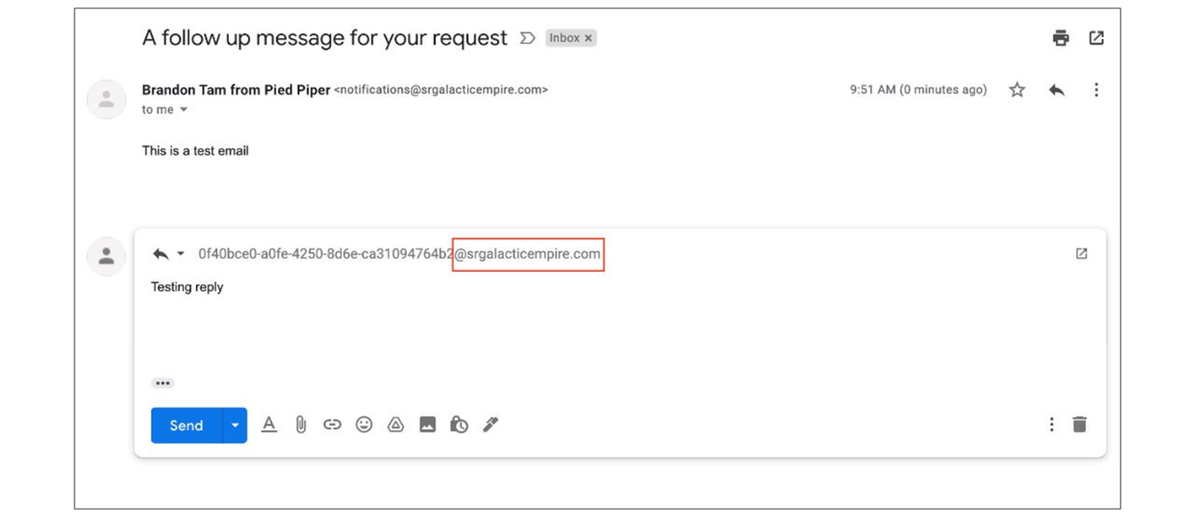
  - Configuring the sub-domain also ensures email replies from the candidate can be received and displayed in SmartRecruiters.
  - SmartRecruiters will not be able to receive candidates' reply emails with a domain that is already used elsewhere (not necessarily by SmartRecruiters). If you attempt to configure using only the domain when it is already in use, you will receive an error message.
Authenticate an Email Domain
Steps
- After an email domain is added, a new group of DNS records associated with that domain will be created.
  - If the status of the DNS records is Creating, check back in later.
  - If the status is Pending Verification, you may proceed to the next step.
  - DNS records creation usually only takes a few seconds and should not take longer than 2 hours.
  - You will need to copy the provided DNS record information and provide it to your IT team if you cannot make these updates yourself. Once the DNS records have been updated, you can proceed with the verification process within SmartRecruiters.
- Select the DNS Records globe icon of the domain.
- A list of CNAMEs and MX DNS records associated with the domain is displayed. Copy these records using the copy icon next to each link and paste them into your own domain DNS records.
- Once all the records have been copied and pasted, select Verify on the bottom of the list, and SmartRecruiters will begin to verify if the DNS records are installed correctly.
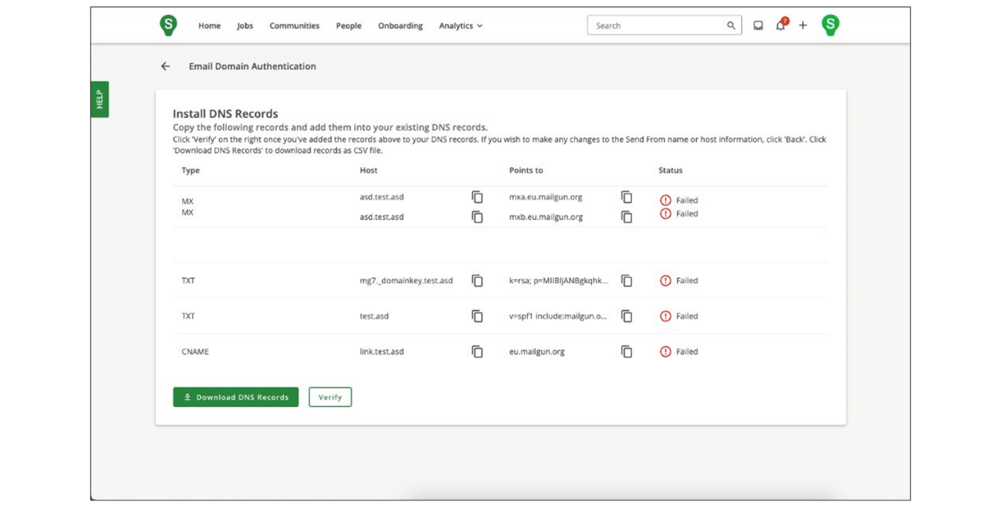
- If SmartRecruiters is able to verify the DNS records, the domain name status will be updated to Verified.
In cases where the DNS records verification failed, select the DNS records icon to revisit the list of CNAMEs and MX records to locate records that do not have the Verified status and make the necessary adjustments to your own domain DNS records.
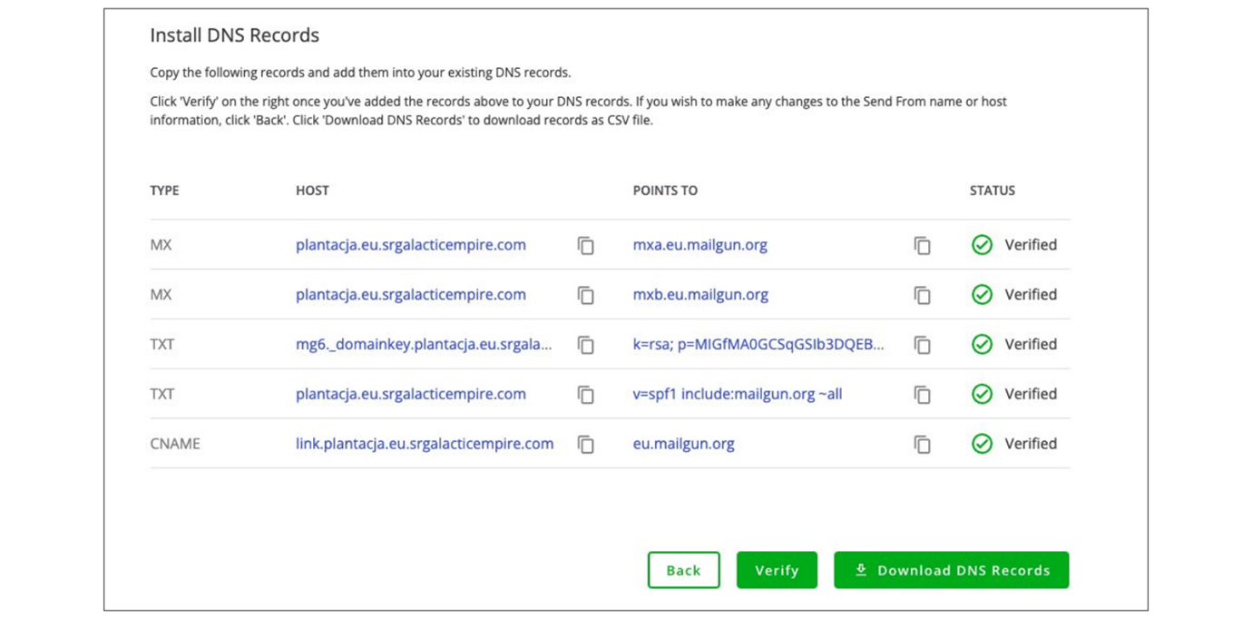
- Navigate back to the Email Domain Authentication page to view the list of domains.
- Switch on the toggle for the selected domain.
The domain you selected must be in the Verified status.
- Select Save to confirm the domain activation.
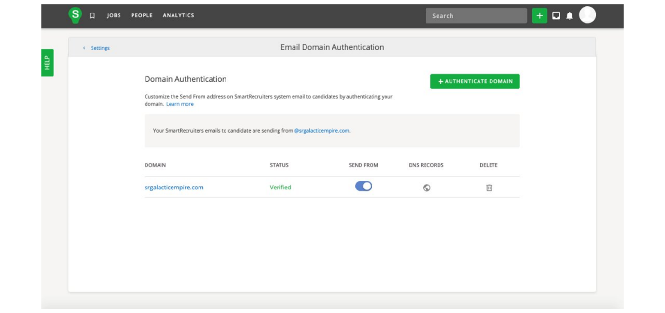
Watch this video for more details about email domain authentication.
This video is for demonstration purposes. Any references made in this video to previous or later videos in this course (including titles, numbers, links, or sequence) may differ from the current course structure. Additionally, some functionalities shown may have evolved over time due to ongoing enhancements or business decisions.
Summary
- Email domain authentication in SmartRecruiters allows you to send emails from your company's domain.
- Configuring your domain requires access to your company's DNS records and involves entering the domain and updating DNS settings.
- Only one domain can be actively used for sending emails at a time.
In this video, we're
going to look at email domain authentication
in SmartRecruiters. So out of the box, all of your emails
that are going out to candidates are being sent from the at
smartrecruiters.com domain. So if you do want to authenticate your own
domain here, you can do so. You will need access to your company's DNS
records to do so. So if that's not you, you'll need some help from
someone within your IT team. You go ahead and click on Authenticate
domain and you'll then be able to enter the domain name that you would
like emails to be sent from. So I'm just using a test example here.
The subdomain to receive email from, it's not actually required. But
once we actually go through to the next steps, we will run a quick
check to the domain's public record to check that it's available. If
it's not available, you'll get an error. And also, if the mail exchange
record is already in use for the subdomain, there'll also be an
error here and you'll then need to provide that domain. So I'm going
to go ahead and click on Next. And that's gone through. So whilst the
check is being run, the status will show as creating. So you can
refresh your screen, come out, come back. It should update relatively
quickly. So normally within a few seconds. And what you should see it
update to is pending verification. So this is good that means I can
go ahead and I can now grab those DNS records and then I can go and
update our company's DNS records, so I'll need this information here.
And as I said if that's not you that can make those updates you can
get someone from your IT team to help you, and then you can go ahead
and verify. So this information is available as with all of our
features and functions in the system, it's available within the help center.
So we do have a detailed article in there that takes you through
the steps that we've just looked at quickly, that gives you a bit
more information on the types of emails that this affects as well. So
if you want to check which emails are in question you can come through
and review this here. Something to note at this time, there is
only one domain that can be in use at one time. So whilst I can come
through and authenticate an additional domain, you'll see that I have to
actually choose which domain it is that I want to send from. So
that's how you can update the domain for your email sent to candidates
in SmartRecruiters. Thank you.

Using SmartMessage for SMS Messaging
Objective
After completing this lesson, you will be able to configure SmartMessage access and consent settings.
SmartMessage for Enhanced Candidate Communication
SmartMessage is a valuable tool within SmartRecruiters that allows recruiters to engage with candidates through SMS and WhatsApp, leading to faster response times and improved communication.
SmartMessage enables hiring teams to message candidates via SMS and WhatsApp directly within SmartRecruiters, without requiring personal phones. It centralizes conversations, allows hiring team members to manage communications directly within the recruiting system, speeds up responses, and supports templates and reporting to scale compliant communication.
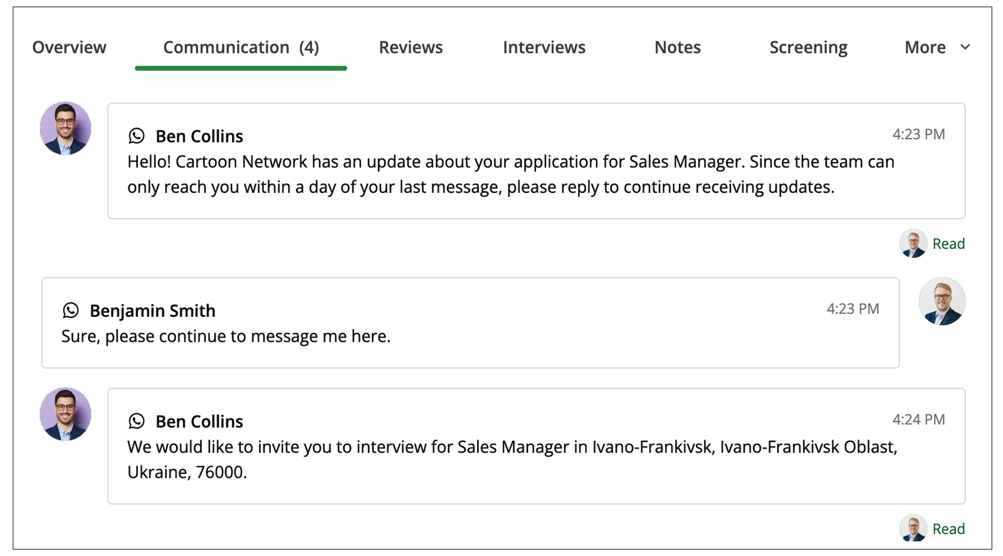
Key Benefits of Using SmartMessage
- Two-way, one-to-one messaging with applicants and prospects in supported countries.
- Unlock the ability to use local and international numbers for globally compliant SMS; WhatsApp channels for global messaging.
- Centralize messages in My Inbox and the Communication tab on the Candidate Profile, with notifications for incoming messages.
- Send interview invitations and reminders via SMS or WhatsApp.
- Usage reporting by user and by country.
- Create and manage SMS/WhatsApp templates with merge fields.
SmartMessage for an Environment
The implementation of SmartMessage, or the addition of a channel or country, can only be done with the assistance of a SmartRecruiters Onboarding Consultant. Please contact your SmartRecruiters AM or CSM to discuss, as it is not a self-service implementation.
Before enabling and activating SmartMessage, you should be prepared to specify which channel(s) to enable and which countries to support.
Timeframe for Implementation
The time to implement SmartMessage varies depending on the country configuration:
Timeframe for implementation | Sending number locations
~ 3 weeks | US, CA, GB, NL, SE, or AU
~ 7 weeks | FR, DE, AT, PL, IL, EE, BE, FL, PR, PH, CH, DK, IE, or with WhatsApp
Administrative Setup: Granting Access
​Before using SmartMessage, administrators need to configure access permissions to ensure that only authorized users can send messages through it.
Configuration Recommendations:
- Administrators should enable Separated Consent for SMS/WhatsApp. This ensures that candidates have an opportunity to consent to messages when they submit their job application, or when a consent request is sent.
- Administrators may configure country-specific SMS Opt-in settings within Global Compliance Settings.
- Administrators must grant access to SmartMessage for their hiring team members. This can be done individually in User Management or at scale using Bulk User Download and Upload. Admins can reassign seats to users at any time if users are not using the feature.
Assign SmartMessage Permissions to Users
Steps
- Navigate to Settings.
- Select User Management in the Permissions section.
- Find the user you wish to provide permissions for and select Edit User.
- In the Access list, enable the SmartMessage checkbox.
- Select Save.
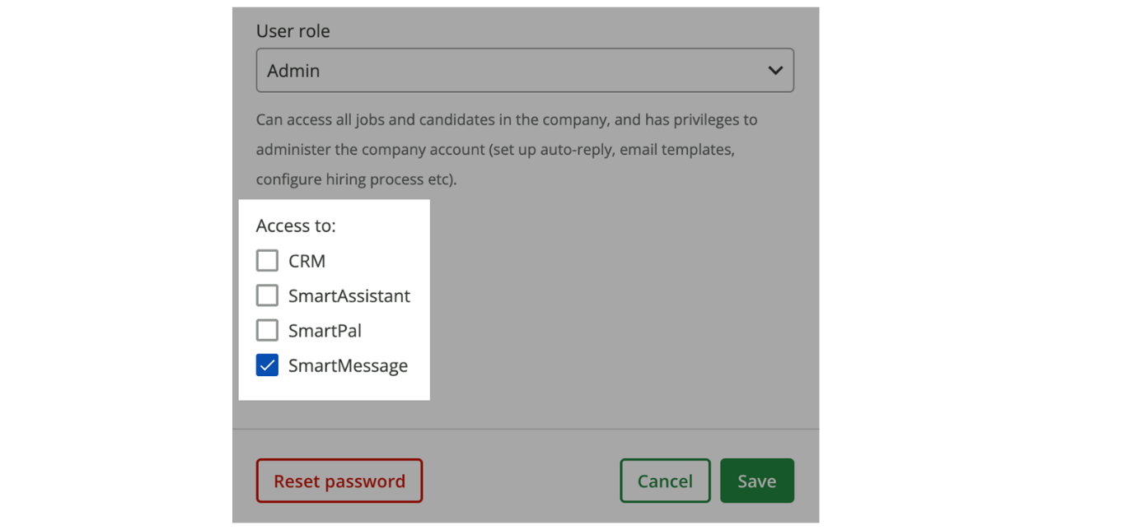
Note
This access works in conjunction with permissions to the Communications tab on a candidate profile and general access to candidates based on hiring team membership or role within the system.
Global Compliance Candidate Opt-in and Consent
Ensuring compliance with regional regulations is crucial when using SMS for communication. Opting in to an SMS conversation with a keyword may be a compliance requirement in some countries, while in others it may only require that identifying information be included in the first SMS. It is the shared responsibility of hiring teams to understand and follow local messaging laws.
MS Opt-In settings can be configured in Global Compliance Settings by selecting a country and toggling SmartMessage SMS Opt-In Settings On or Off.
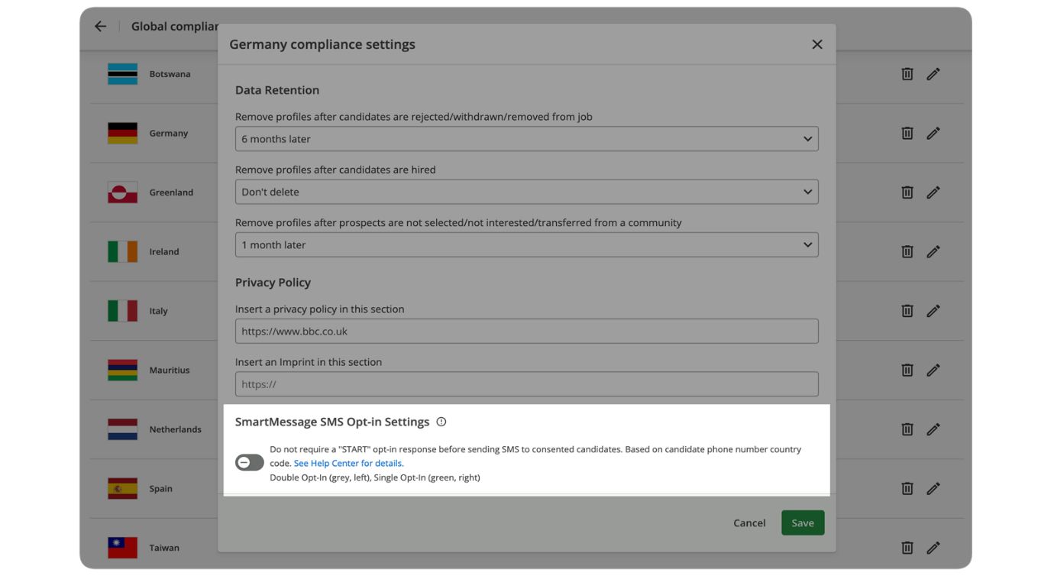
These Global Compliance Country settings are matched to a candidate’s phone number, and the language of the opt-in message is determined by the Job Ad. This ensures that every candidate reachable via SMS will receive the correct compliance message in the correct language. We recommend that hiring teams get familiar with local SMS compliance laws and regulations before removing the SMS Opt-in requirement for any country.
SmartRecruiters provides a setting to manage candidate opt-in preferences:
- Opt-In Requirements:
  - Toggled Off: (Positioned to the left, gray colored) - Requires Double Opt-In; candidates need to reply START to the initial message for communications to continue.
  - Toggled On: (Positioned to the right, green colored) - Only requires Single Opt-In, a default message will be sent (stating your name, company, and purpose of outreach), but allows you to message the candidate immediately without requiring them to Opt-in.
- Country-Specific Settings: Establish Opt-in settings by country to comply with varying regional regulations. Consult your legal department or review regional requirements before configuring this setting.
Managing Candidate Consent
Consent is always required to begin conversations with candidates, regardless of location, messaging channel, or opt-in model. The conversation window will remain locked until the candidate provides consent.
Be sure to require consent at the application for SMS/WhatsApp, so that candidates may consent during the apply process. Consent may also be requested by the hiring team and delivered to the candidate via email as a link.
You can request consent above the rich text editor in the Communication tab or My Inbox, or in the Consent Status pane on an applicant profile.
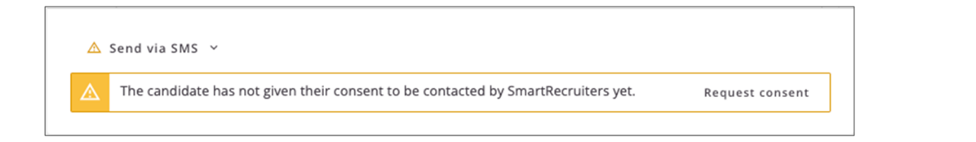
In the candidate application, you can also view the consent status to see whether a candidate has consented to SmartMessage (or other modules that use communications).
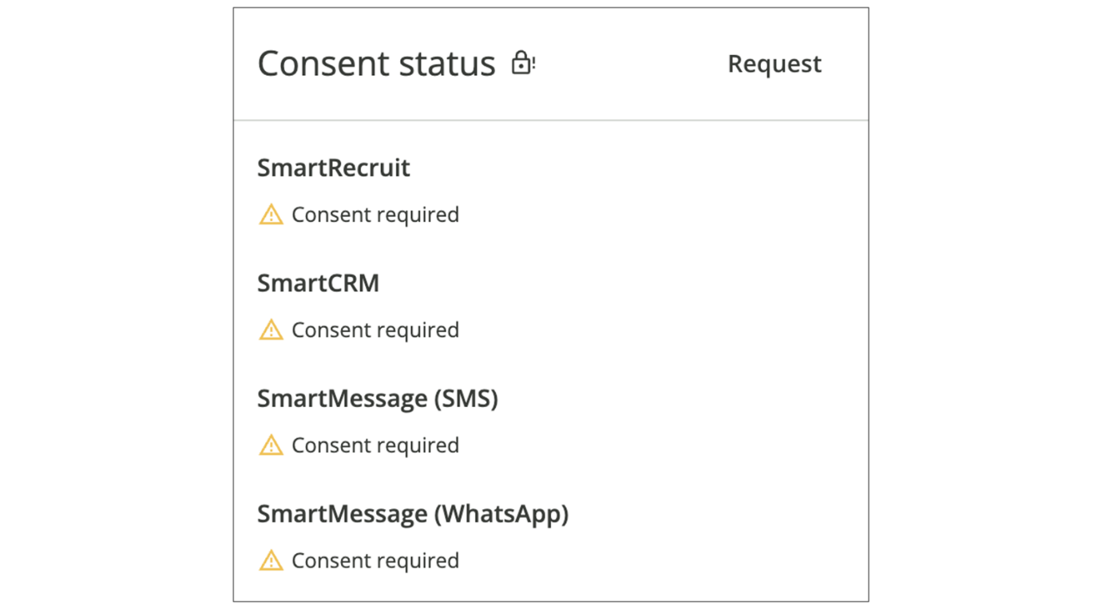
Message Candidates Utilizing the Communication Tab
Once the administrative setup is complete, a candidate has opted in to receive SmartMessage SMS or WhatsApp messages, and hiring teams can use SmartMessage to begin sending communications to candidates.
Steps
- Navigate to Candidate by selecting the Jobs tab, selecting the relevant job, and selecting the candidate's name.
- Within the candidate profile, select the Communication tab.
- Choose Messaging Option. Depending on your configuration, you'll see options for SMS, WhatsApp, or both.
  - Send via WhatsApp: If using WhatsApp, the candidate must have contacted you within the past 24 hours. You can send a message prompting them to reply to initiate the conversation.
  - Send via SMS: If opt-in is required, the candidate must reply START before you can send further messages.
  - Send via SMS: If opt-in is not required, a default message will be sent, and you can continue the conversation immediately.
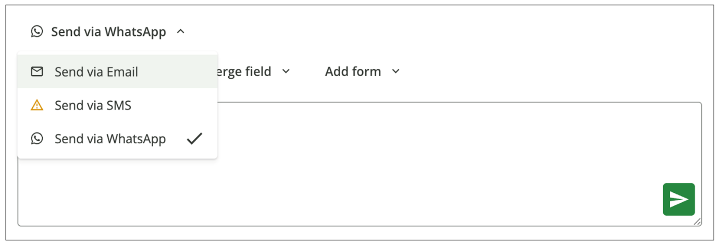
Note
Currently, SmartRecruiters does not send email notifications for candidate replies via SmartMessage. Therefore, it's essential to use the Inbox feature to stay up to date.
SmartMessage for Interview Scheduling
When scheduling an interview or sending candidates to self-schedule their own interview, SMS and WhatsApp options can be found below the Communication to Candidate section. This will present options for the channel and the message content to be sent via SMS or WhatsApp.
Candidates will be able to confirm or decline when scheduling or select and confirm times when self-scheduling.
SmartMessage interview invitations are available for traditional Scheduling and Self-Scheduling, but not Mass Self-Scheduling, Group Interviews, or Automated Self-Scheduling.
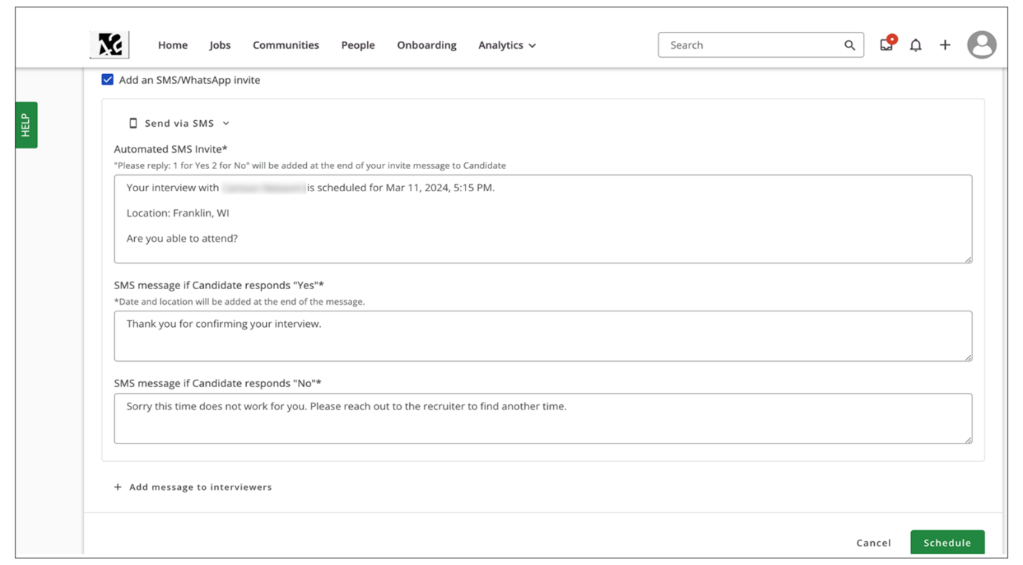
SMS or WhatsApp interview reminders can be set and configured from the candidate's Interviews tab. Select Remind for a scheduled interview event, and configure the number, timing, and verbiage of the reminder(s) to be sent. As needed, reminders can be deleted or recreated.
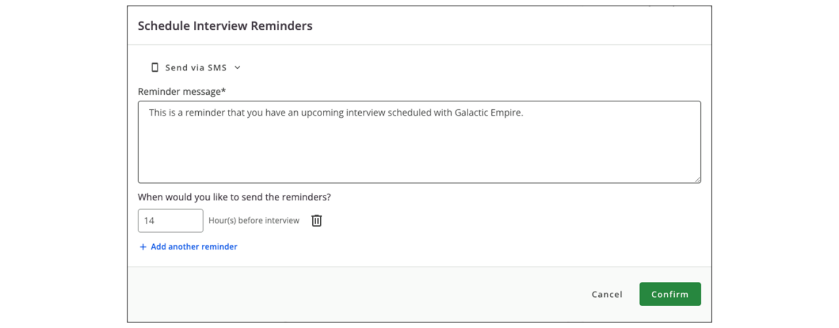
Watch the video below for more details about using SmartMessage.
This video is for demonstration purposes. Any references made in this video to previous or later videos in this course (including titles, numbers, links, or sequence) may differ from the current course structure. Additionally, some functionalities shown may have evolved over time due to ongoing enhancements or business decisions.
Summary
- SmartMessage allows recruiters to engage with candidates through SMS and WhatsApp, leading to faster response times and improved communication.
- Administrators need to configure access permissions to ensure the correct users have the access they need to send messages through SmartMessage.
- Ensuring compliance with regional regulations is crucial when using SMS for communication.
- Consent is always required to begin conversations with candidates, regardless of location, messaging channel, or opt-in model.
- When scheduling an interview or sending candidates to self-schedule their own interview, SMS and WhatsApp options can be found below the Communication section.
H i there. Today we will be walking
through the SmartMessage functionality together. This functionality
allows you to contact your candidates via SMS or WhatsApp,
increasing candidate response times to your inquiries. We will be looking
at managing access to SmartMessage from an administrative perspective.
We'll go through some consent options available and how you
can start sending and receiving messages through the candidate's
profile. So let's dive right in. As you can see here, I'm logged into
my SmartRecruiters environment. And there are two aspects of SmartMessage that you need to set up from an administrative perspective
before you can use SmartMessage. So I'm going to go into my Settings
page and first head over to User management. This is where I
can add my users in, inactivate users, but I am going to click
Edit into my own profile here. And if SmartMessage has been enabled
properly by SmartRecruiters, you are going to be able to see an
access to checkbox for SmartMessage. So by clicking on this checkbox
here, you are enabling this user to start messaging candidates.
And this is going to work in conjunction with permissions to the
Communications tab on a candidate profile, as well as access to
candidates in general by being a part of the hiring team or being in a
more elevated role in our system. The second step that you are going
to want to take before using Smart Message is within global compliance,
and we're going to talk about candidates opting in. So if I click
Global compliance, it takes me to the area where I can add in my data
retention rules. I can add my privacy policy, but now you are going to see
a SmartMessage SMS opt-in settings toggle here. So what this does is
it either requires or it will not require of your candidates opting in
to the text message thread via SMS before you start messaging them. So
what I have done here is if it is toggled off, this will actually
require your candidates to type in start before you can start messaging
them. If I have this turned off, what I will do on my side is there's a
default message that I will send to them. It states my name, the
company I'm with and the purpose of me reaching out to them. And that's
just part of the policy of using SMS. But after sending that initial
message, I could start messaging them immediately without them having to
opt in. So you can see that you're going to establish this opt-in
setting by country. And that's because different regions have different
regulations and requirements around opting in. So before I'm making a
decision here, what I would highly recommend is you reach out to your
legal department or check out your regional requirements surrounding
consent before checking this opt-in setting. Once you've set up your
opt-in settings, now we can go into the candidates profile and take a look
at what it is to message candidates and receive messages from candidates
as well. So I'm going to head over to my jobs tab and I'm going
to go into my implementation job here. So once in my implementation
consultant role, I'll be able to see all the candidates that have applied
to this position and I'll click on Arnold's name. And once within
the candidate profile, all my Smart Message activity is going to happen
in the Communications tab. So the same tab that you would email
your candidates out of. When Smart Message is set up, you'll see either
one or two options, depending if you wanted to use SMS, WhatsApp, or
both. So I'll start with WhatsApp first. So WhatsApp has its own
regulations around opt-in. The candidate must be in touch with you within
the past 24 hours in order for you to start messaging them. So I can
click on this if the candidate does have SmartMessage and this would
send them a message prompting them to message me back so I can start
my conversation with that candidate. SMS is going to depend on the
option settings that we just took a look at. So here you could see
that I do not require my candidate to type in start before I can
start messaging them, but I do have to send this message to them in
order for our conversation to begin. So you can see that this is a
default message that cannot be customized, but it states my name,
the corporation I'm with, what it's in regards to also opt out
instructions if I don't want this conversation to continue. So once I
do that, I can go on ahead and click on this option here. And this is
going to message the candidate. And then I could just start my
conversation with them here. Another way you can use SmartMessage is
going to be through interviews. Now, it doesn't matter if you are
scheduling a new interview or using the self-schedule feature. I'm going
to just go in and schedule a new interview. And what I am able to do
is I'll choose an interview time. This looks good, right? So
I would just go about how I normally would schedule
my interviews. Let's add an invite to the candidate.
I'll choose, let's see, an invite letter friendly. So all of this looks very similar
to the process you probably followed today, But I am going
to see an additional option here for a SmartMessage.
So if I click add an SMS or WhatsApp invite, this is going
to supplement this email that's going out to the candidate,
inviting them to an interview. So if I click on this, you'll have
the option to either send SMS or WhatsApp, depending on what's configured for your environment, and then I could come in here and I could
see the automated message that we'll send to the candidate. So I can
make changes if I need to customize this and then I can schedule so that
I'm reaching out to them using two forms of communication, just increasing
the chances of them responding to me quickly. So if I go and
schedule that, I will be able to see all that communication again in our
Communications tab. So you'll be able to track exactly all the activity
that has taken place within the SmartMessage functionality. A common
question that we get in regards to SmartMessage is, do I get an
email notification if a candidate has responded? And right now, as the
product stands, you do not get an email communication about replies. So
it's really important to incorporate the use of the inbox, which is
up here into your training and enablement of your SmartMessage users.
So if I use my inbox, I'm just going to click on this, I will be able
to see all of candidates I've had direct communication with on the
left-hand side. I'll be able to see if someone has responded to me recently,
and then I could start responding to them directly within the inbox
itself. So a good way to keep up with your communication instead of
going into individual candidates profiles and checking there. You
will also see similar to this, right? The red circle with notifications in
here. So you could see if you have received something recently. So
it's a good habit to get into to check your inbox every single day or
multiple times a day to keep up with your communications. That'll wrap
up SmartMessage functionality. So thank you so much for your time and
we'll see you in the next video.

Sending Bulk SMS Messages with SmartMessage
Objective
After completing this lesson, you will be able to describe the process of sending bulk SMS messages to applicants.
Candidate Messaging in Bulk using SmartMessage
To enable faster, more scalable candidate messaging, SmartMessage Bulk Messaging for SMS is available. Sending bulk SMS messages in SmartRecruiters is a streamlined way to communicate with multiple candidates simultaneously. This feature saves time and effort compared to individually messaging each applicant.
Hiring teams will be able to multi-select candidates, send a SmartMessage SMS in bulk, and view updates and results for the bulk send.
Send Messages in Bulk to Candidates
Steps
- Navigate to the Applicant page of the relevant job posting in SmartRecruiters.
- Select the candidates you wish to message. You can either manually select each candidate or use Select All.
  - To select all applicants, click the checkbox next to Applicant.
  - Note that by default, only 30 applicants are loaded per page.
  - If the job has more than 30 applicants, scroll down to load additional applicants. Once loaded, the newly visible applicants will not be automatically selected. Uncheck the Select All box, then recheck it to include all applicants in the selection.
- After selecting the recipients, go to the Actions dropdown menu.
- Choose Send Message.
A window will appear, allowing you to choose your message settings before sending.
- Change the method of communication from email to SMS.
- Type your message in the provided text box.
  - You can personalize the messages by adding merge fields. Alternatively, you can use a pre-created message template.
  - Keep in mind that SmartRecruiters sends a separate message to each candidate individually; group messaging is not supported.
- Once the message is ready, select Send Message.
- A pop-up notification will confirm that your text messages are being processed.
Message Status Notifications
- Monitoring Message Status: After sending the messages, you can track their status by clicking the notification icon at the top-right corner of the screen. This will provide an overview of successful and unsuccessful sends.
- Troubleshooting Failed Messages: The user sending the bulk message will also receive an email notification. If any messages fail to send, click on the error notification for more details. Common reasons for failure include missing or incorrectly formatted phone numbers in the candidate's profile.
- Resolving Errors and Retrying: Correct any errors, such as adding missing phone numbers. Then, click the Retry All Failed button to resend the failed messages.
- Reviewing Sent Messages: Successful texts will be listed in the notification area. You can click a candidate's name to view their profile and see the message sent in the Communication tab.
- Refreshing Status (For Large Batches): When sending a large bulk message, you can refresh the status to get the most up-to-date information on the sending progress. The summary page also displays the exact time the message was sent and the communication method used. The View More button lets you see the exact content of the message.
In the screenshots below, you will see examples of message status notifications.
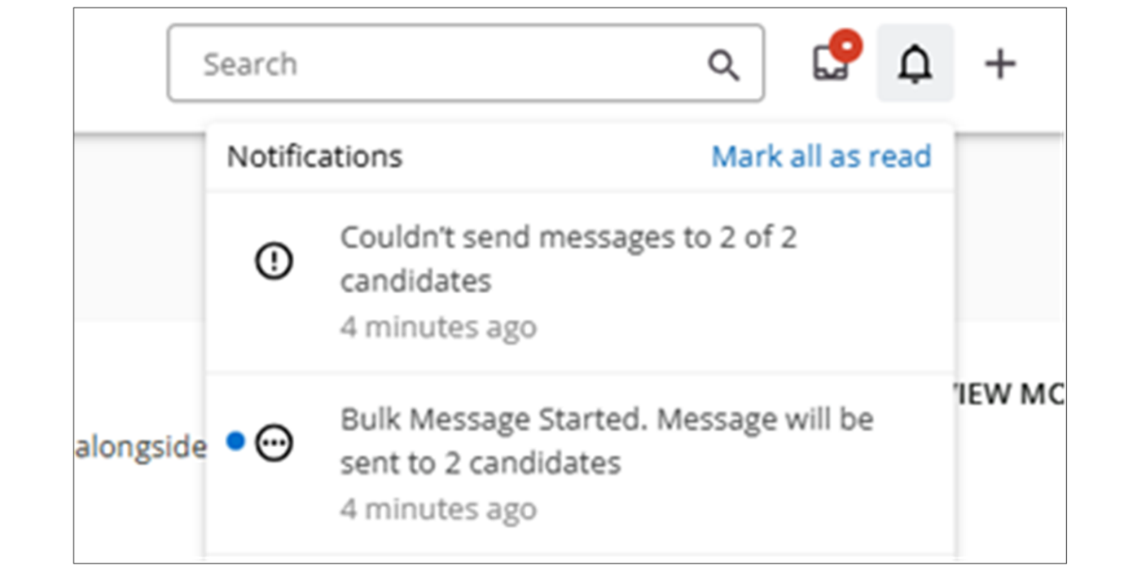
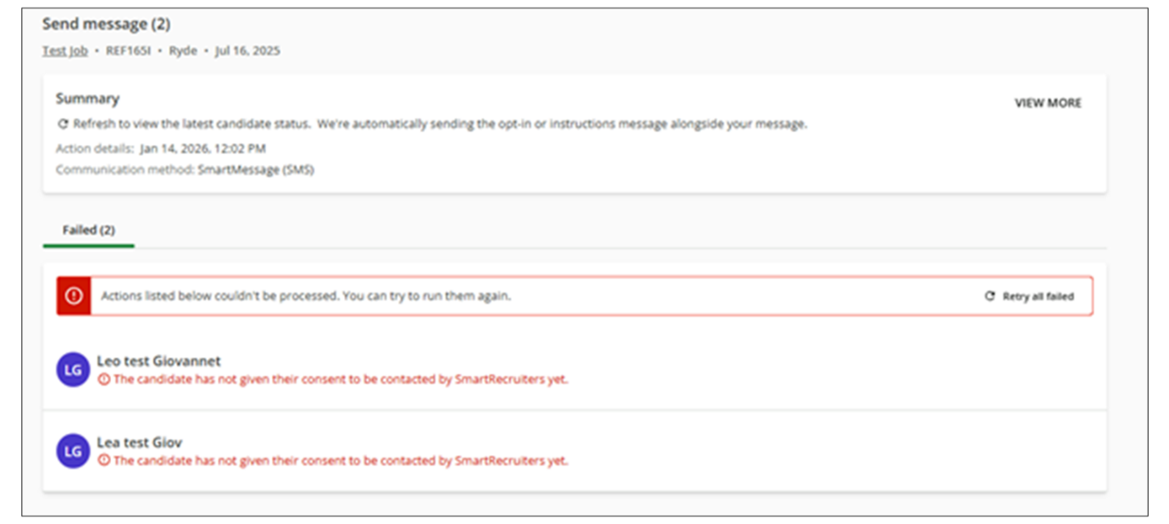
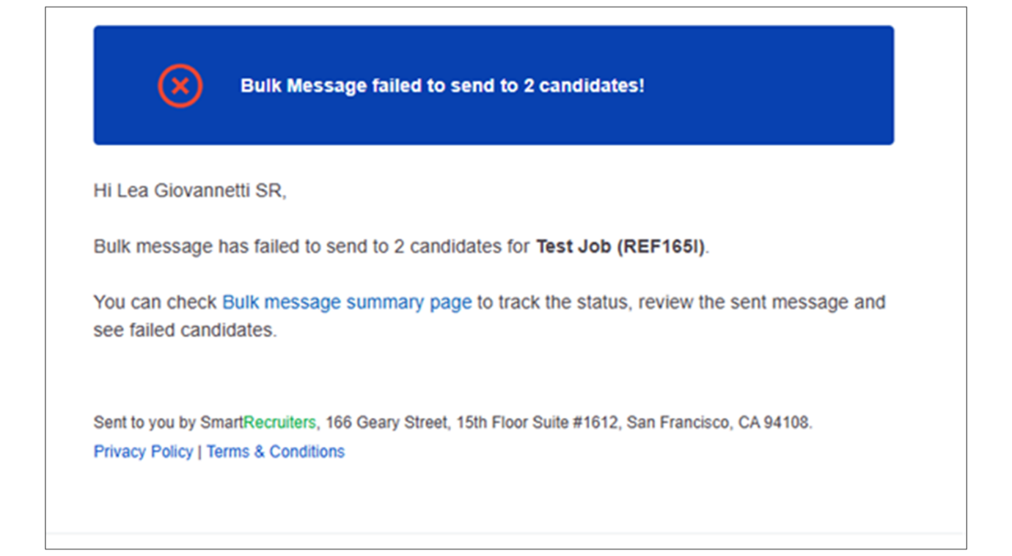
Watch the video below for more details about sending bulk SMS messages.
This video is for demonstration purposes. Any references made in this video to previous or later videos in this course (including titles, numbers, links, or sequence) may differ from the current course structure. Additionally, some functionalities shown may have evolved over time due to ongoing enhancements or business decisions.
Summary
- Bulk SMS messaging in SmartRecruiters allows you to communicate efficiently with multiple applicants simultaneously.
- You can select individual applicants or all applicants for a job, remembering to load all applicants on the page if there are more than 30.
- The system provides status updates and error reporting, allowing you to identify and resolve issues with message delivery, such as missing phone numbers.
In this video we're going
to be looking at how to send a bulk text message
to applicants and Smart Recruiters. Currently I'm
on my account manager job and I want to send a message to
multiple candidates at one time, saving me from having to go into
each candidate profile and send a message individually. To do that from
the applicant page you can select who you want to send the text to.
And if you want to do a select all you would click the checkbox next
to applicant and notice that it's only selecting 30 applicants even
though there are 32 in this job. In order to select more than the
default 30 applicants that are loaded on the page you'll have to
scroll down to load more applicants. So you'll notice that when
the final two load they're not checked so what I would need
to do is go back to the top uncheck the select all
and recheck it. Now you'll see that all of my
applicants have been selected if I needed to send it
to everybody on this job. In this example, I'm only
going to be sending it to a handful of people, so I'm going
to choose those people now. And once I've selected who was
going to receive the text message, I can go up to the bulk actions
drop-down and select send message. So very similar to sending a
bulk email message, in this case I want to change my method of
communication from email to SMS. And here you can type
your message. You have the option to add merge fields
as well. Or if you've created a template, you
can select that here. Note that this will send a separate message to each candidate individually. Currently, group messaging
is not supported in SmartRecruiters. Once I'm
ready to send, I can send my message by clicking
the Send Message button. And you'll notice I get a pop-up
telling me that my text messages are in process of being sent.
Once all my messages have been sent, I can go up to my notification
icon at the top right and it will give me an overview of what
was successful and if there were any unsuccessful sends. So you can
see here one was sent successfully but four out of the five couldn't
receive it. If I want more details I can click on that error
here and on the summary page here I will get more details about
why these text messages failed. So in this case these four
candidates didn't have a phone number on their profile. Another reason
that it could fail would be that the phone number was entered
incorrectly or is missing digits. After you've corrected any errors
that you may have, you can retry all failed by clicking the Retry all
failed button here on the right. And then any successful text will show
up here, and if you want you can click directly to the candidate
profile. And if I go to my Communication tab here you'll see the message
that was just sent. Going back to the Summary page, you You have
the option to refresh the status if you're sending a very large bulk
message. You can see when exactly it was sent in the communication
method, and clicking the view more button on the right will show
you exactly what the message was. Thank you for watching
this video on sending bulk text messages in SmartRecruiters.

Creating and Using SMS Message Templates for SmartMessage
Objective
After completing this lesson, you will be able to create SmartMessage SMS templates for efficient communication.
SmartMessage Templates
To enable faster, more scalable candidate messaging with SMS and WhatsApp, SmartMessage Templates and Merge Fields are available to SmartMessage customers. Hiring teams can create and send SmartMessage templates in the same way email templates are used.
SmartMessage Templates, as an extension of Email Templates, can be created, edited, or deleted. Templates can be made for just email, just SmartMessage, or for both. The Communication Templates landing page includes a Channel column that indicates the Template Type (email, SmartMessage, or both).
The same MergeFields available to email templates are also available in SmartMessage templates.
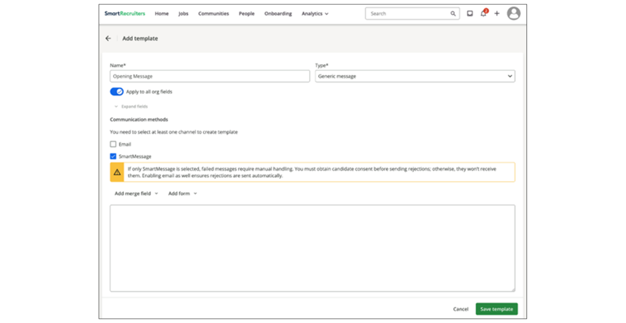
Create an SMS Template
Steps
- Navigate to Settings.
- Select Communication Templates section under Templates. Here, you'll find both email and SMS templates, identifiable by the Channel column.
- Select Add Template.
- Give your template a descriptive name.
- Select Message Type as Generic message.
Ensure the message type is set to Generic message, as SMS templates are only compatible with this type. If you choose a different message type, the SMS option will not be available.
- Add Org Fields (Optional).
You can add specific Org fields to this template, like email templates.
- Select SmartMessage as the Communication Method.
If you would like to use the template as email AND SMS, select both checkboxes.
- Insert the message content.
SmartMessage templates do not have formatting options. You can add merge fields and Unicode emojis to your text. If an emoji is incompatible, it will appear as the emoji's name with colons on each side.
- Select Save Template. Your message will now be available in both email and SmartMessage formats. You can also create solely SmartMessage templates if you don't need the email component.
Send an SMS Message from the Inbox
SMS messages can be sent either from your Inbox or from the application on a job.
Steps
- Go to your Inbox and select a candidate you've been conversing with via SMS.
- Ensure the candidate has consented to receive SMS messages.
- At the bottom of the chat, choose Send via SMS.
- Select your desired SmartMessage template.
- Edit the template if necessary and add any additional merge fields.
- Click Send.
- The message will be delivered to the candidate's phone. You can see their response after they text back, and you refresh your inbox.
Send an SMS Message from the Application Communication Tab
Steps
- Navigate to the job and click on the candidate.
- Go to the Communication tab, where you'll see any emails and texts exchanged with the candidate.
- Choose Send via SMS.
- Select the desired template.
- Click Send.
- The message will be delivered to the candidate, and you can continue the conversation using email or SMS templates.
Watch the video below for more details about creating and using templates.
This video is for demonstration purposes. Any references made in this video to previous or later videos in this course (including titles, numbers, links, or sequence) may differ from the current course structure. Additionally, some functionalities shown may have evolved over time due to ongoing enhancements or business decisions.
Summary
- SMS templates can be created from the Communication Templates section under Settings, enabling efficient communication.
- SMS messages can be sent from the Inbox or the Communication tab on an application, streamlining the communication process.
- Using SMS templates with merge fields and emojis enhances personalization and engagement.
Hi, in this video we're going to
be looking at how to create an SMS template as well as how to send
an SMS message with a template. To create the template,
on my Settings page, I'm going to go to the Communication Templates section under Templates. Here you'll see both email
and SMS templates, and you can tell what type of template
it is by the Channel column. So far we have only
email templates, so we're going to be creating
an SMS template today. You also have the option if
you wanted to edit a template. So if, for example, I wanted
the disclosure email template to have both an email and SMS
template, I can click Edit and then I can click SmartMessage,
and add that template. And note that SmartMessage templates only work with the generic message type. For this example, I'm just going
to create a new template. So I'm going to click the Add
Template button on the right, I'm going to give my template a name.
You'll notice that since I'm on a generic type of message,
I have the options for both email and SMS. But if I were
to change this to a different type of message, you'll notice
now SMS is no longer available. So again, SMS can only be used with
the generic message type. You have the option to add specific org fields
to this template as you can with any email template, or by clicking
the toggle here, you can apply all org fields to this template. So
first, I'm going to create my email template I'm going to give it a
subject and then I'm going to enter in the body of my message. You'll
notice on the email message area I have a lot of formatting options.
But now that I want to add a Smart Message template as well, SmartMessage
template does not have those options as it's going to be sent through
a text. You do have the option to add merge fields to your text and
you also have the ability to add any Unicode emojis. If you add an emoji
that is not compatible instead of the emoji showing up in the text
it will show up as the name of the emoji with colons on each side. So
I'm just gonna again paste the same message since it's a short message
it can go for both email and Smart Message and again I will add a merge
field here just for example, and you can add any other
merge fields you need. And then when I'm ready to
save I can click Save Template. So now you'll see my message
is both an email and a Smart Message. And of course you can
also create solely SmartMessage templates as well if you don't
need the email component. So now I'm gonna send this
text and you can send the text either from your inbox or
from the application on a job. I'm gonna go to my inbox first and
I already have a candidate here that I've been conversing with via
SMS. So they have consented and now when I go down to the bottom of our
chat, I can choose send via SMS. And now you'll see I have my template
option here so I just have the one SmartMessage template at this
point. I can add that template I have the option to edit it again if I need
to, and I can also add additional merge fields if there's anything
I forgot, and then I can send. Now on my phone I see the message
has been delivered, and then as the candidate I can text back
as well. Now you can see I text back after I refresh my inbox, and
you can see the response from the candidate. You can also send a
templated text via the communication tab on an application. So I'm
going to navigate to this job, I'm going to click on the candidate
and under the Communication tab you'll see any emails or texts I've
been conversing with this candidate. I'm just going to send the same
template again to show you how that would work and it's very similar
to how it worked in our inbox. I'm going to choose send via SMS. I'm going to select that template
and then I'm going to send. Now I can see it's been delivered
to the candidate and I can continue to converse with them using
email templates or SMS templates. Thank you.

